Multiple-Cutout Subtraction

Definition
# Source: AI Source: Provided by: [Data Path: Persons Table -> ID Column: 1, Name_En Column: Motasem Essam] -> From: [ChatGPT] on [7/25/2026]
Multiple-Cutout Subtraction is a method of forming a modified solid by removing two or more distinct regions of material from an existing solid. These cut-outs may have different geometric shapes, dimensions, depths, and positions.
The removed regions may be arranged independently or combined into a more complex pattern. They can extend through the entire solid, penetrate only partially, or remove portions of its edges and surfaces.
The resulting solid contains multiple openings, recesses, gaps, or missing sections.

Simple Definition
# Source: AI Source: Provided by: [Data Path: Persons Table -> ID Column: 1, Name_En Column: Motasem Essam] -> From: [ChatGPT] on [7/25/2026]
Multiple-cutout subtraction means removing two or more portions of material from a solid to create multiple openings or cut-out regions.

Geometric Representation
# Source: AI Source: Provided by: [Data Path: Persons Table -> ID Column: 1, Name_En Column: Motasem Essam] -> From: [ChatGPT] on [7/25/2026]
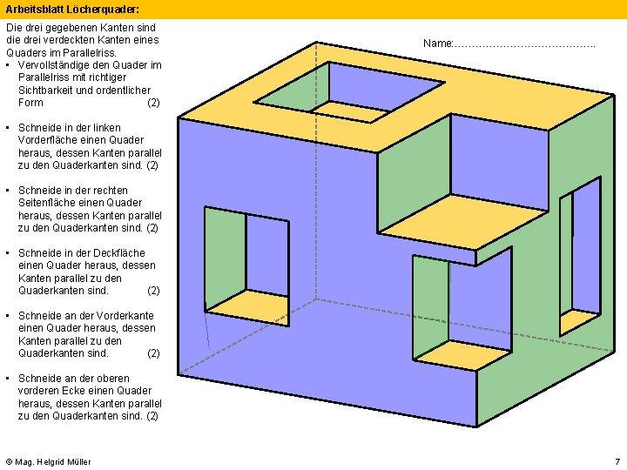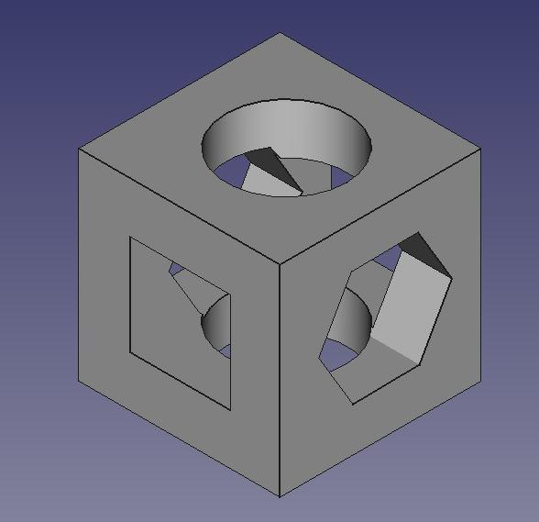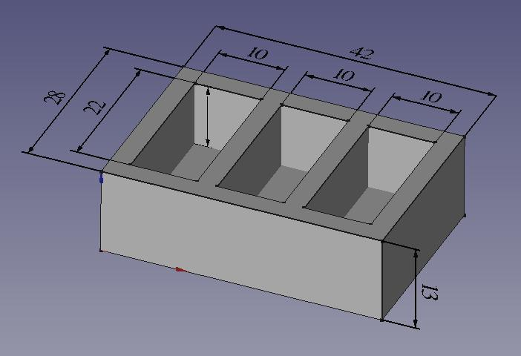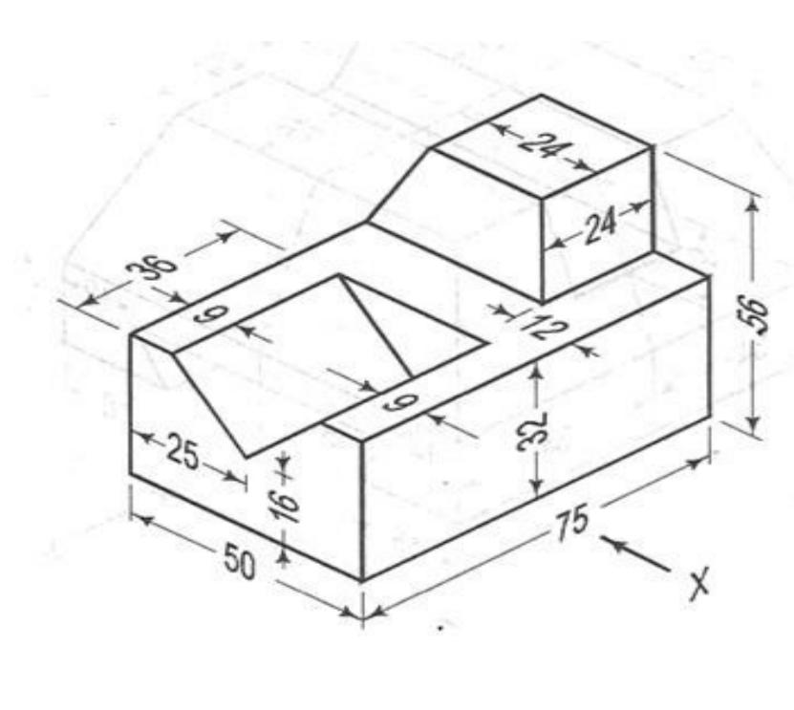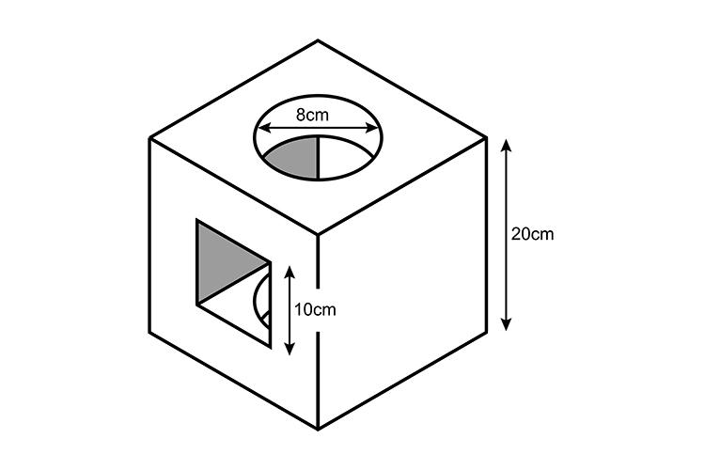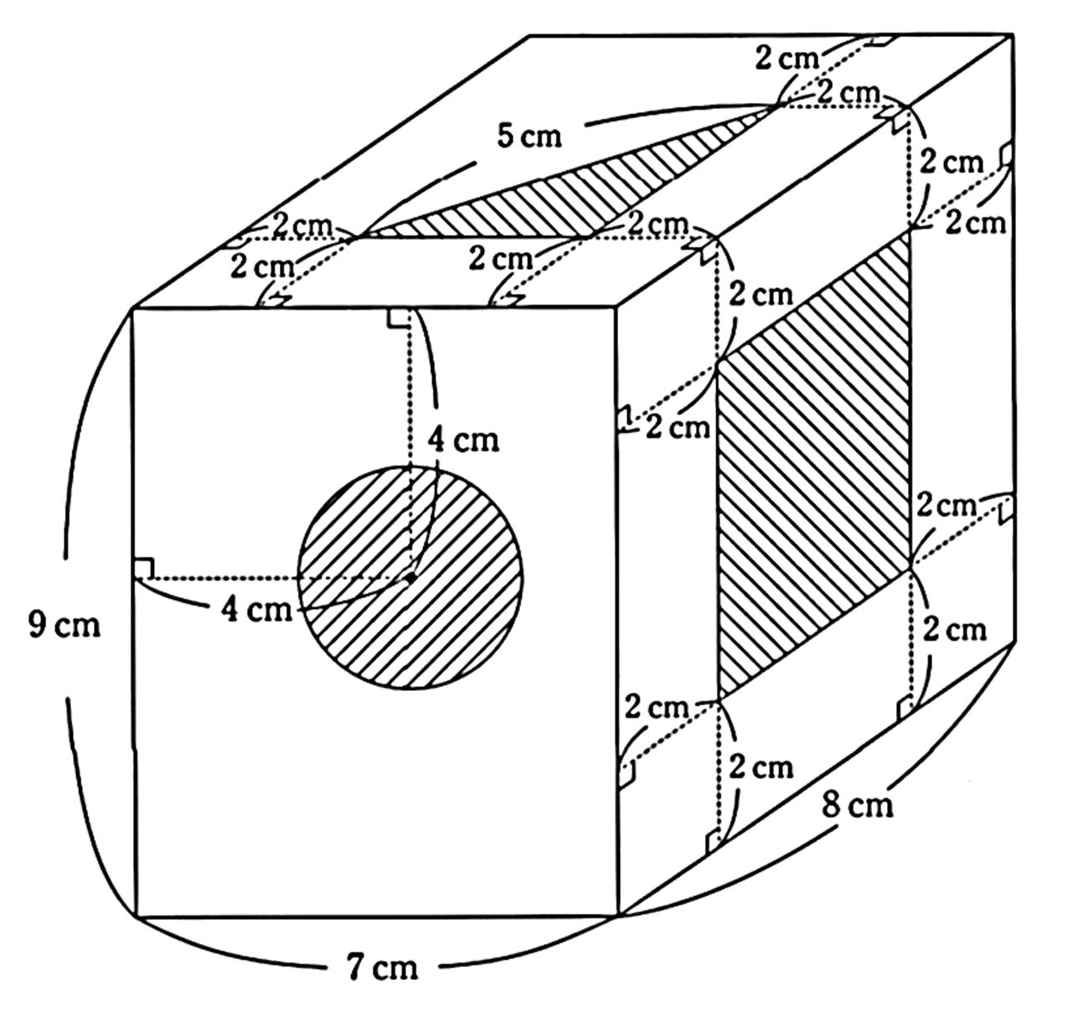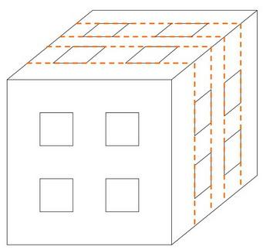
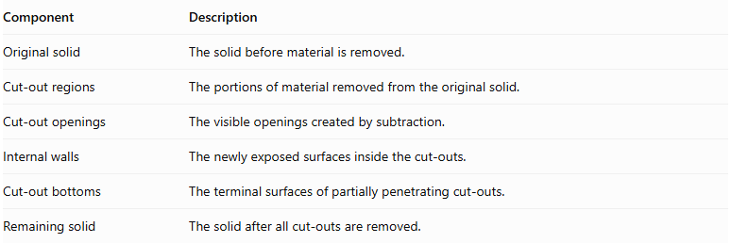
Component | Description
Original solid | The solid before material is removed.
Cut-out regions | The portions of material removed from the original solid.
Cut-out openings | The visible openings created by subtraction.
Internal walls | The newly exposed surfaces inside the cut-outs.
Cut-out bottoms | The terminal surfaces of partially penetrating cut-outs.
Remaining solid | The solid after all cut-outs are removed.

Main Classification
# Source: AI Source: Provided by: [Data Path: Persons Table -> ID Column: 1, Name_En Column: Motasem Essam] -> From: [ChatGPT] on [7/25/2026]
Multiple-cutout subtraction can be classified according to the geometric shapes of the removed regions.

Multiple Rectangular Cutouts
# Source: AI Source: Provided by: [Data Path: Persons Table -> ID Column: 1, Name_En Column: Motasem Essam] -> From: [ChatGPT] on [7/25/2026]
Two or more rectangular portions are removed from the original solid.
- Cut-out shape: Rectangular.
- Arrangement: May be parallel, adjacent, opposite, or distributed.
- Example: Multiple rectangular openings in a block.

Multiple Square Cutouts
# Source: AI Source: Provided by: [Data Path: Persons Table -> ID Column: 1, Name_En Column: Motasem Essam] -> From: [ChatGPT] on [7/25/2026]
Two or more square-shaped regions are removed.
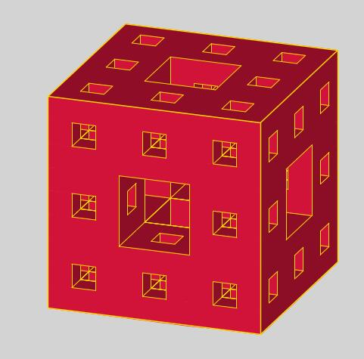
- Cut-out shape: Square.
- Dimensions: May be equal or different.
- Example: Several square openings in a solid block.

Multiple Circular Cutouts
# Source: AI Source: Provided by: [Data Path: Persons Table -> ID Column: 1, Name_En Column: Motasem Essam] -> From: [ChatGPT] on [7/25/2026]
Two or more circular regions are removed from the solid.
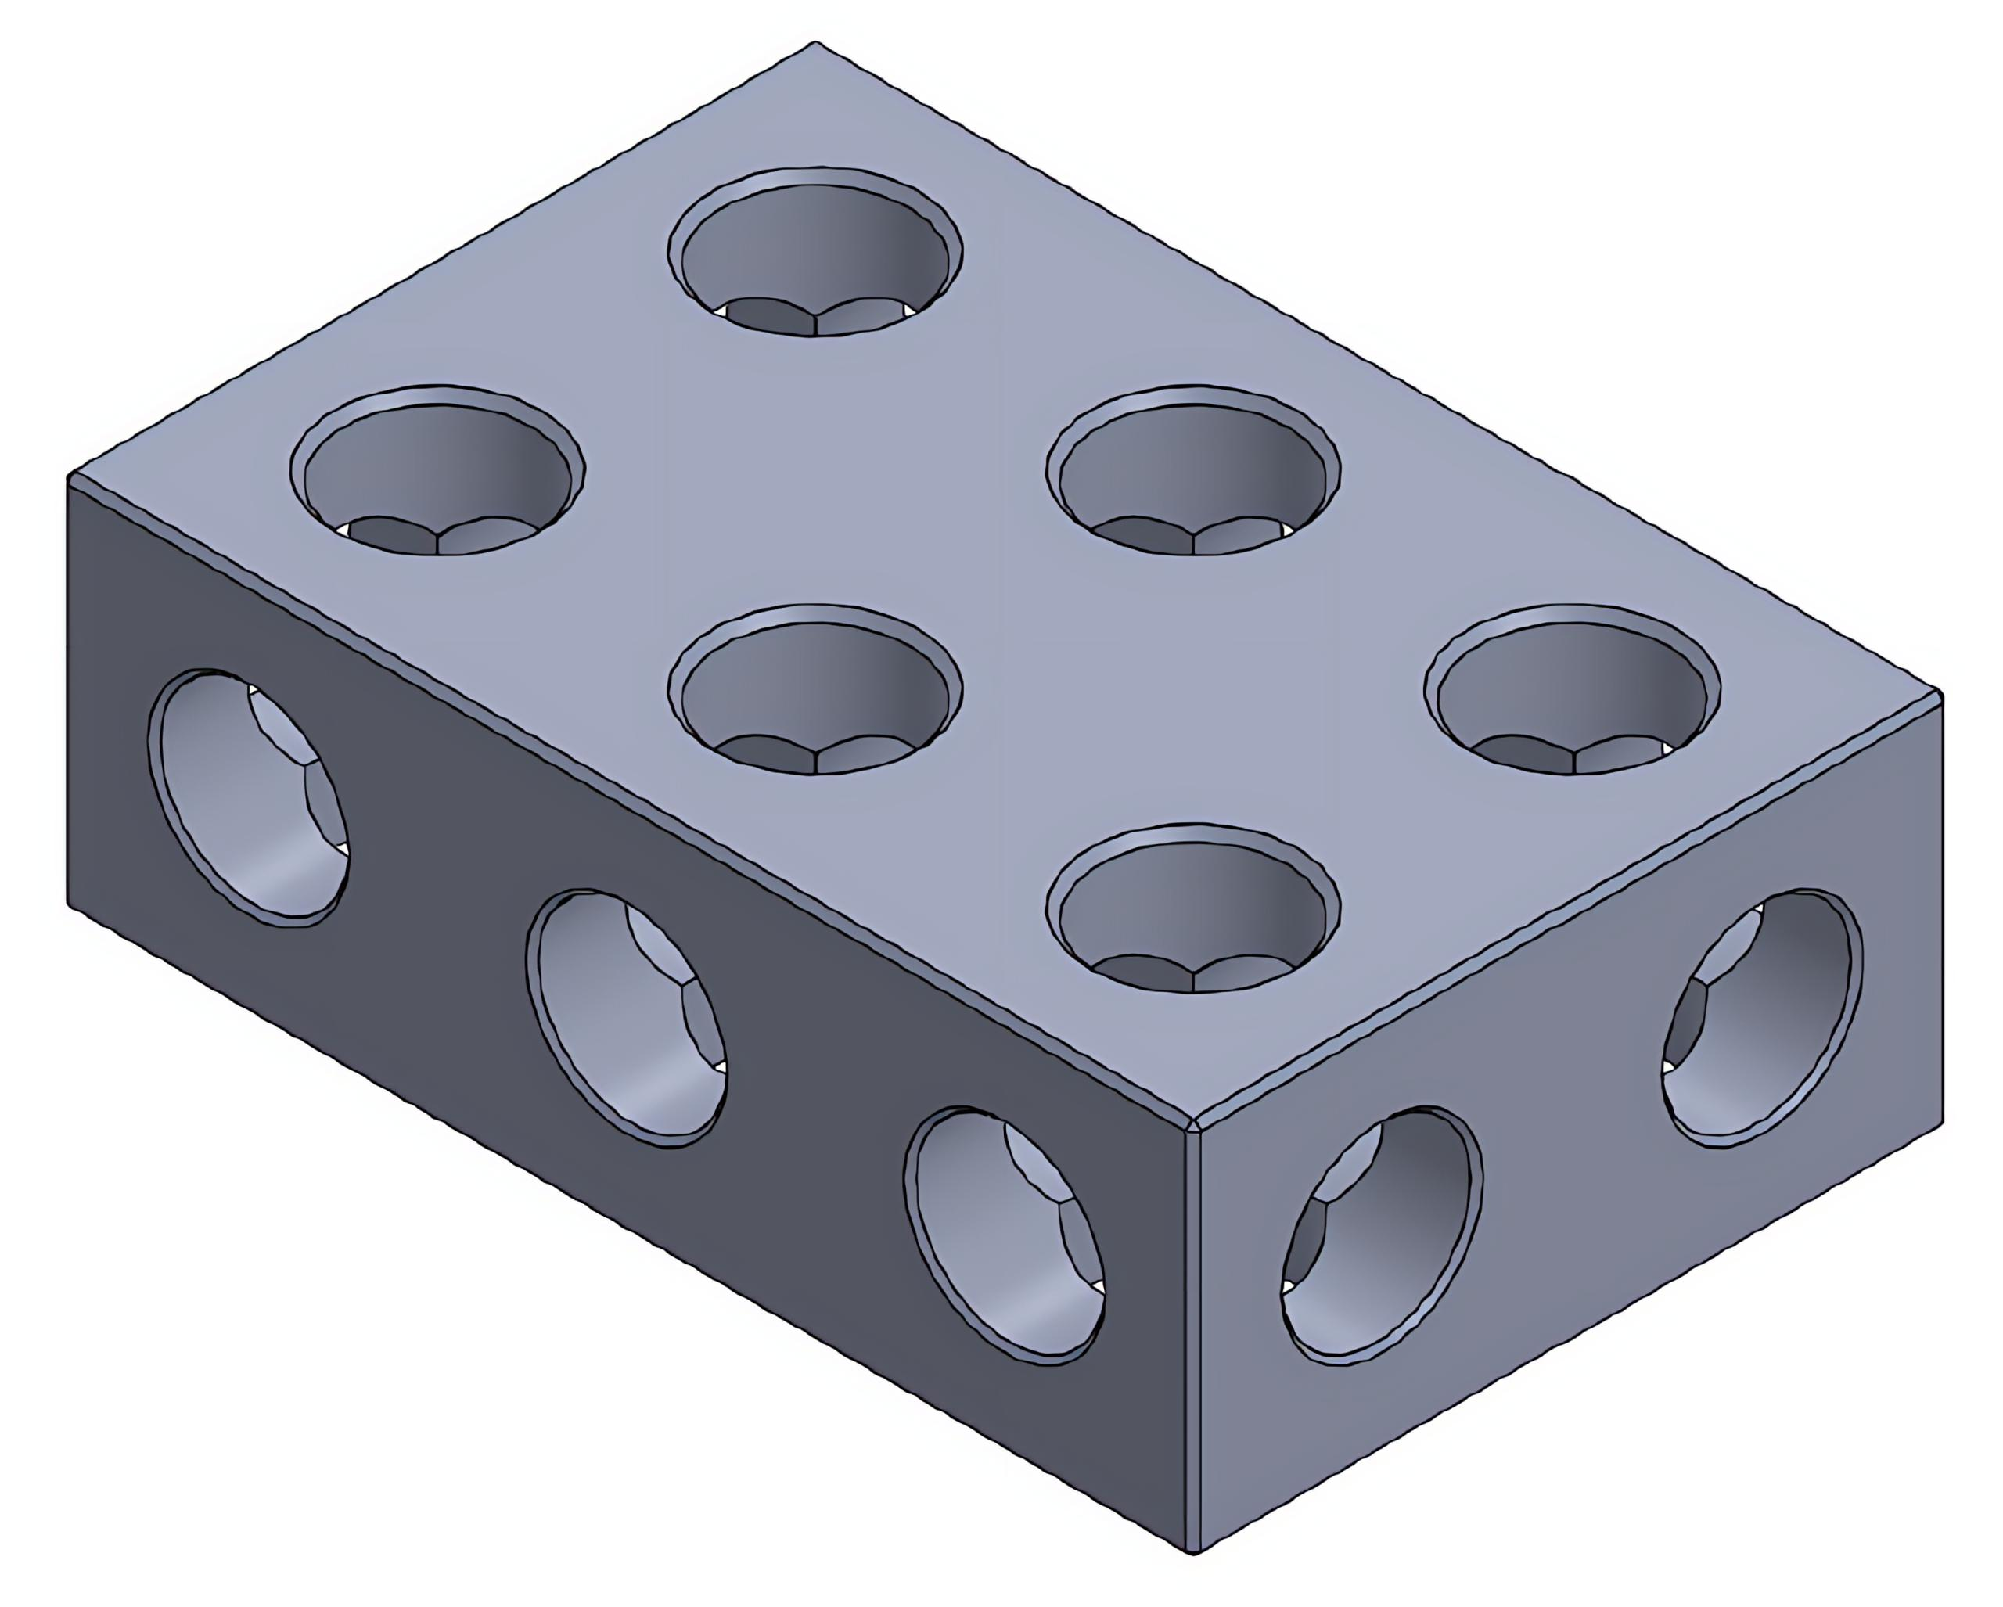
- Cut-out shape: Circular.
- Removed solids: Commonly cylindrical.
- Example: Multiple cylindrical holes in a rectangular prism.

Multiple Triangular Cutouts
# Source: AI Source: Provided by: [Data Path: Persons Table -> ID Column: 1, Name_En Column: Motasem Essam] -> From: [ChatGPT] on [7/25/2026]
Two or more triangular regions are removed.
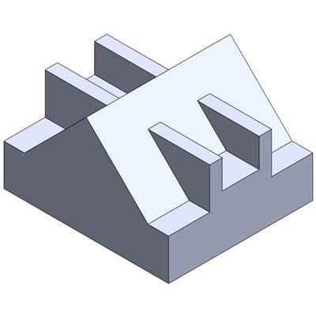
- Cut-out shape: Triangular.
- Removed solids: May be triangular prisms or other triangular-based solids.
- Example: Multiple triangular openings in a prism.

Multiple Polygonal Cutouts
# Source: AI Source: Provided by: [Data Path: Persons Table -> ID Column: 1, Name_En Column: Motasem Essam] -> From: [ChatGPT] on [7/25/2026]
Two or more polygon-shaped regions are removed.
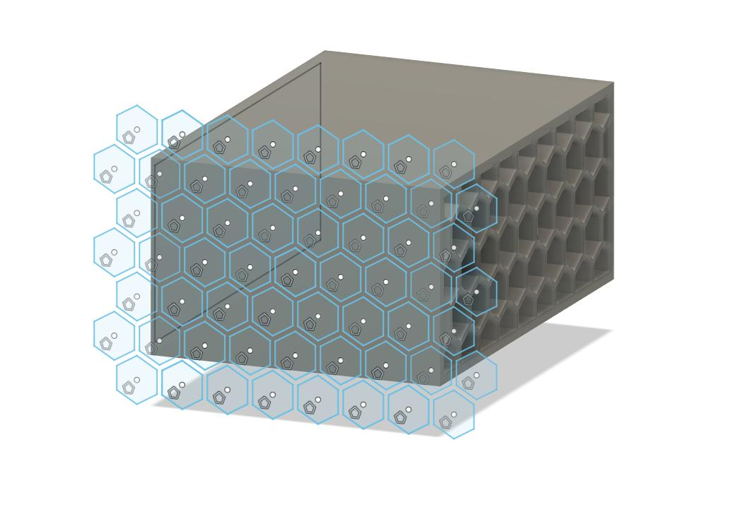
- Cut-out shape: Polygonal.
- Examples: Pentagonal, hexagonal, and octagonal cut-outs.
- Example application: Polygonal openings in a solid panel.

Multiple Curved Cutouts
# Source: AI Source: Provided by: [Data Path: Persons Table -> ID Column: 1, Name_En Column: Motasem Essam] -> From: [ChatGPT] on [7/25/2026]
Two or more curved regions are removed.
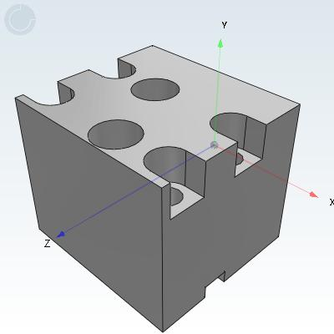
- Cut-out shape: Curved.
- Removed regions: May be cylindrical, spherical, or irregularly curved.
- Example: Multiple curved recesses in a solid.

Multiple Mixed-Shape Cutouts
# Source: AI Source: Provided by: [Data Path: Persons Table -> ID Column: 1, Name_En Column: Motasem Essam] -> From: [ChatGPT] on [7/25/2026]
Two or more cut-outs with different geometric shapes are removed from the same solid.
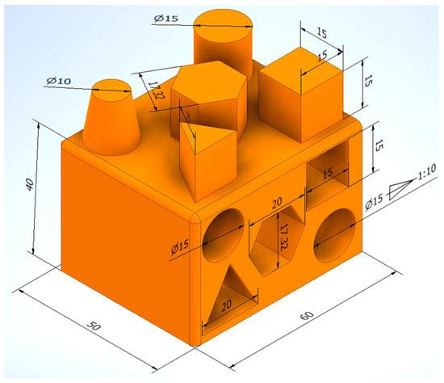
- Cut-out shapes: Different geometric shapes.
- Arrangement: May be regular or irregular.
- Example: A block containing rectangular, circular, and triangular cut-outs.

Classification by Cut-Out Type
# Source: AI Source: Provided by: [Data Path: Persons Table -> ID Column: 1, Name_En Column: Motasem Essam] -> From: [ChatGPT] on [7/25/2026]
Multiple cut-outs can also be classified according to the subtraction operation used to create them.
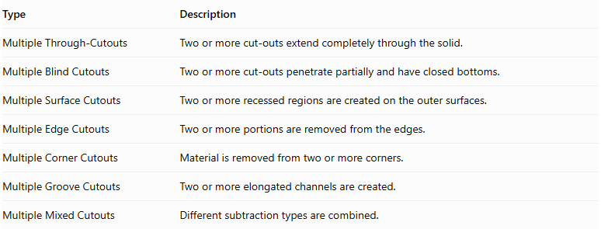
Type | Description
Multiple Through-Cutouts | Two or more cut-outs extend completely through the solid.
Multiple Blind Cutouts | Two or more cut-outs penetrate partially and have closed bottoms.
Multiple Surface Cutouts | Two or more recessed regions are created on the outer surfaces.
Multiple Edge Cutouts | Two or more portions are removed from the edges.
Multiple Corner Cutouts | Material is removed from two or more corners.
Multiple Groove Cutouts | Two or more elongated channels are created.
Multiple Mixed Cutouts | Different subtraction types are combined.
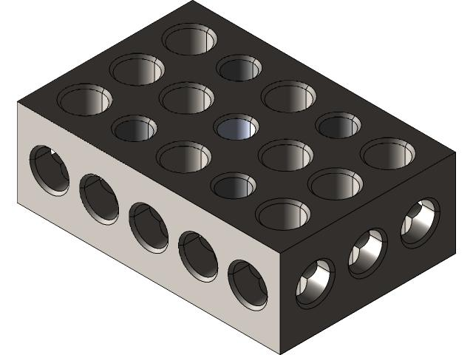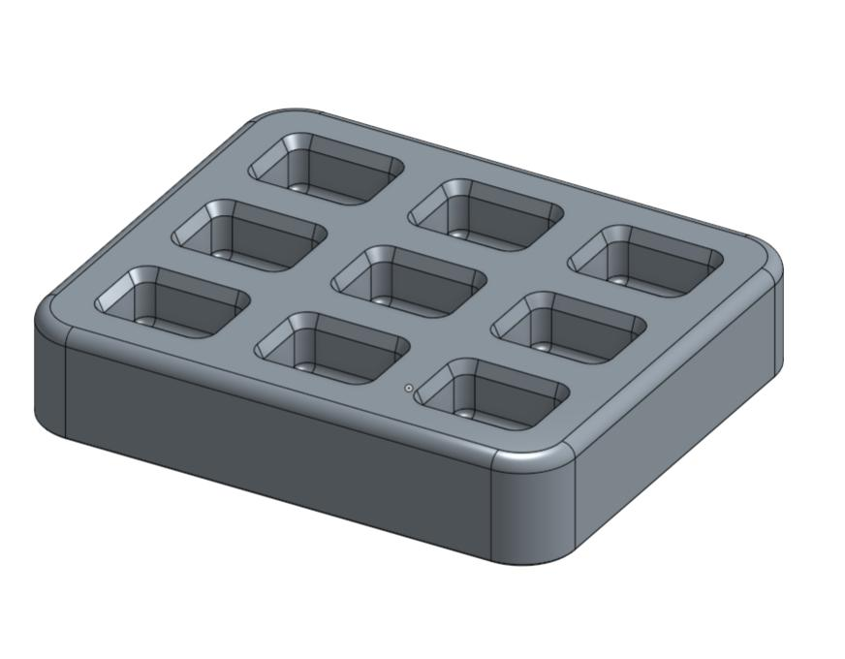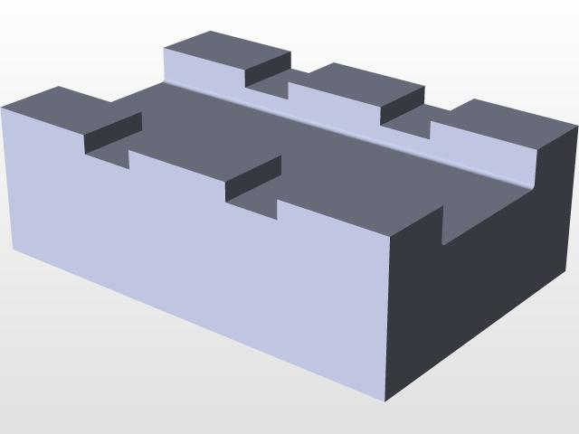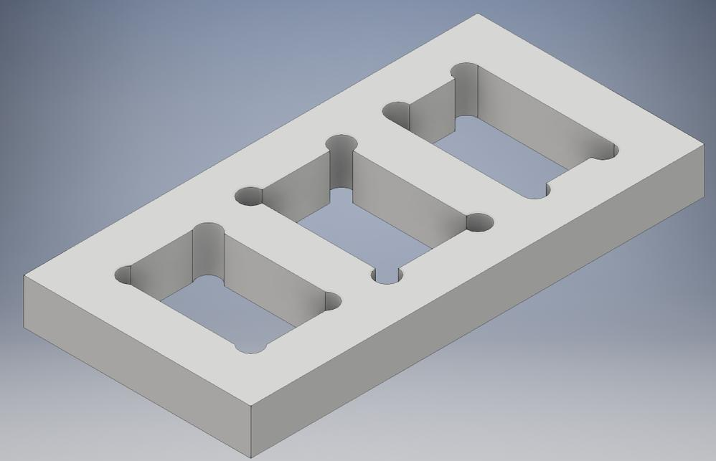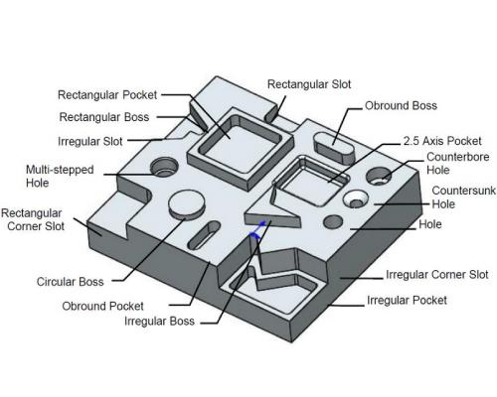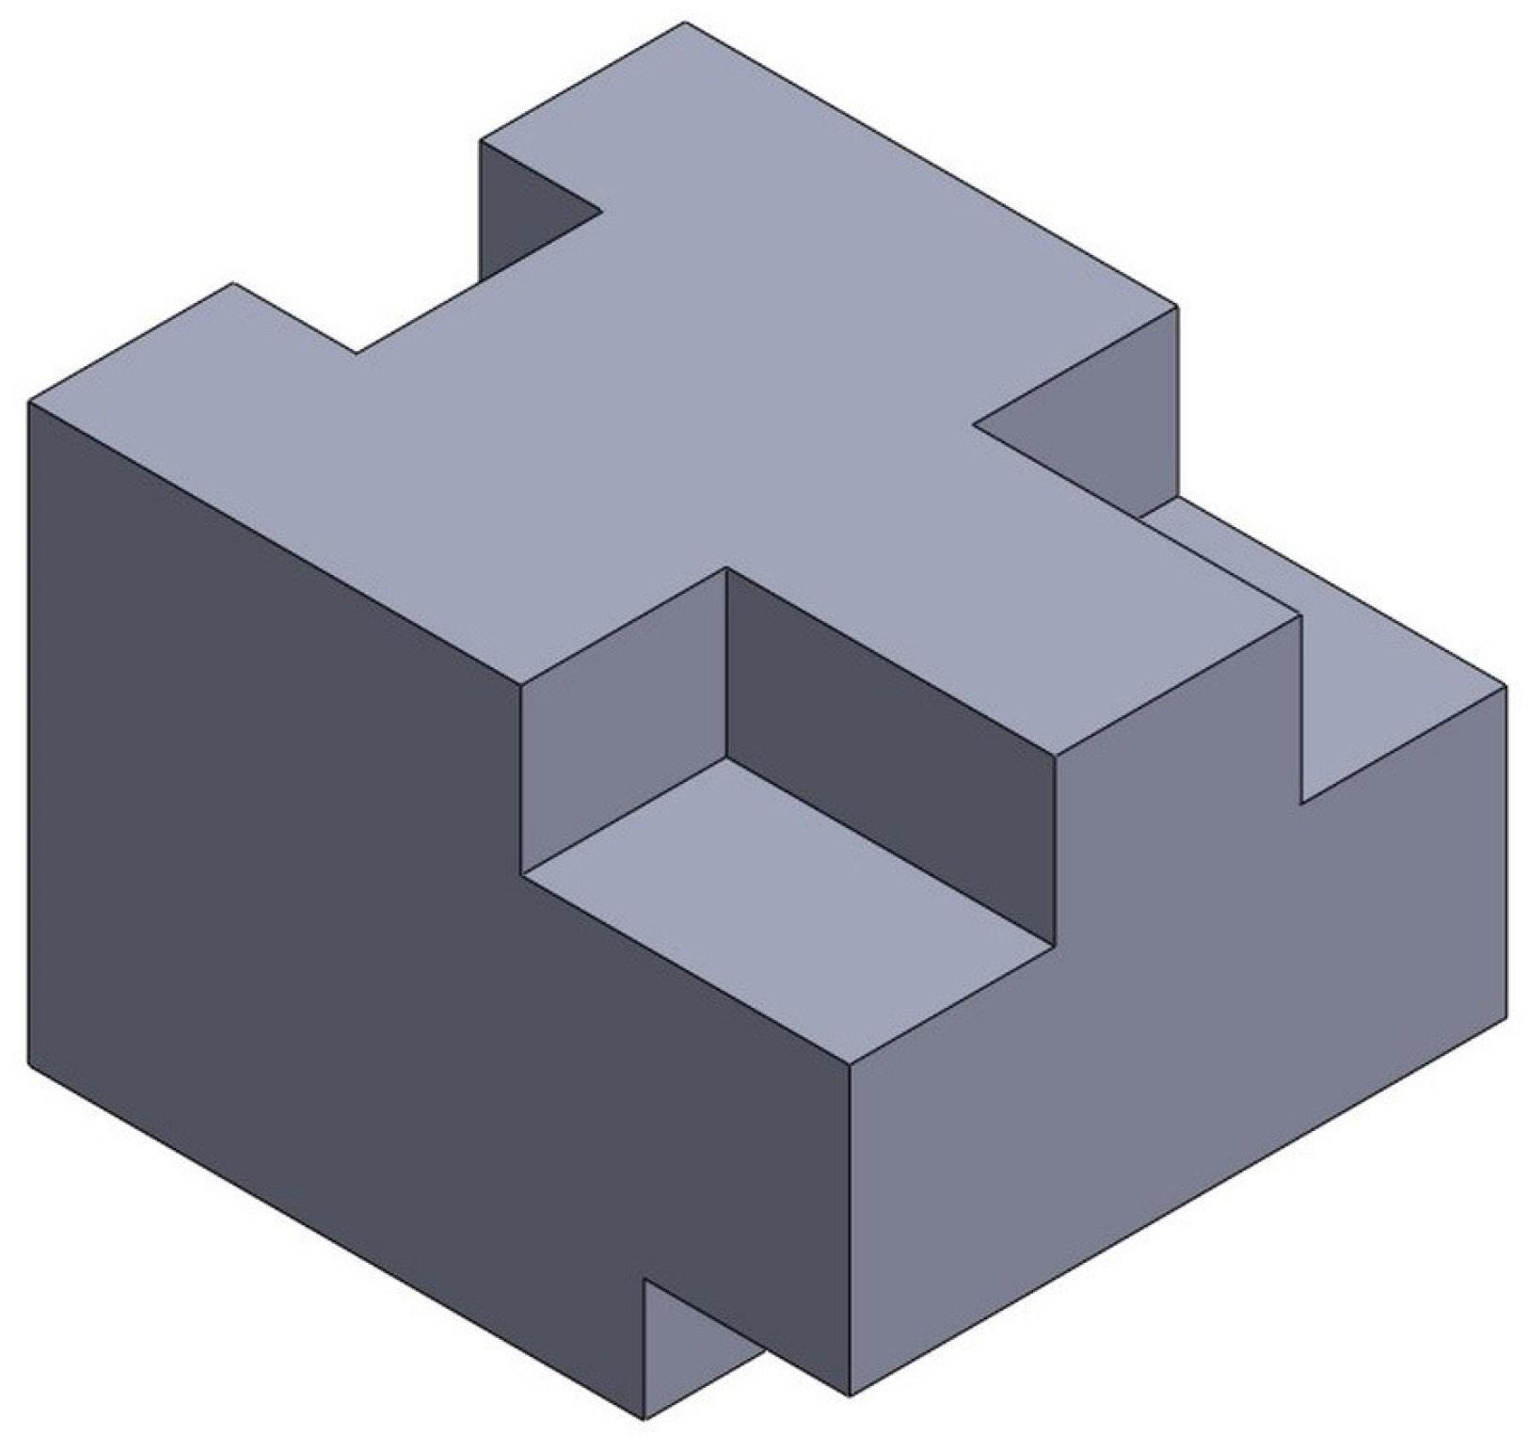

Classification by Arrangement

Parallel Cutouts
# Source: AI Source: Provided by: [Data Path: Persons Table -> ID Column: 1, Name_En Column: Motasem Essam] -> From: [ChatGPT] on [7/25/2026]
Two or more cut-outs are arranged parallel to one another.
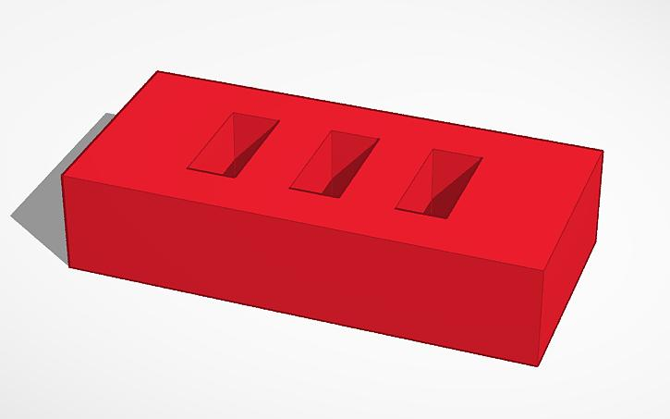

Adjacent Cutouts
# Source: AI Source: Provided by: [Data Path: Persons Table -> ID Column: 1, Name_En Column: Motasem Essam] -> From: [ChatGPT] on [7/25/2026]
Two or more cut-outs are positioned next to one another.
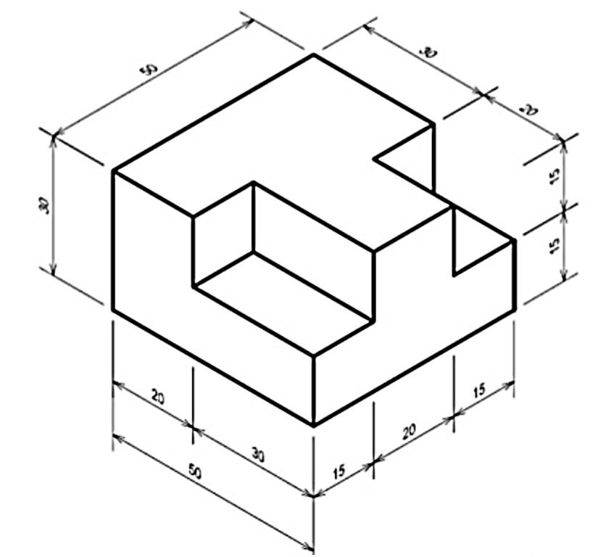

Opposite-Side Cutouts
# Source: AI Source: Provided by: [Data Path: Persons Table -> ID Column: 1, Name_En Column: Motasem Essam] -> From: [ChatGPT] on [7/25/2026]
Cut-outs are located on opposite faces or sides of the original solid.
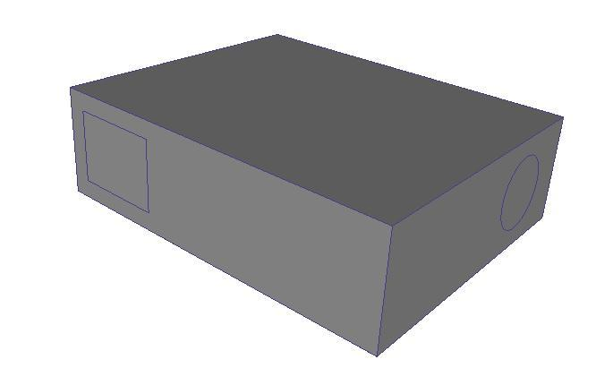

Symmetrical Cutouts
# Source: AI Source: Provided by: [Data Path: Persons Table -> ID Column: 1, Name_En Column: Motasem Essam] -> From: [ChatGPT] on [7/25/2026]
Cut-outs are positioned symmetrically around a plane, axis, or center.

Asymmetrical Cutouts
# Source: AI Source: Provided by: [Data Path: Persons Table -> ID Column: 1, Name_En Column: Motasem Essam] -> From: [ChatGPT] on [7/25/2026]
Cut-outs are positioned without a symmetrical arrangement.
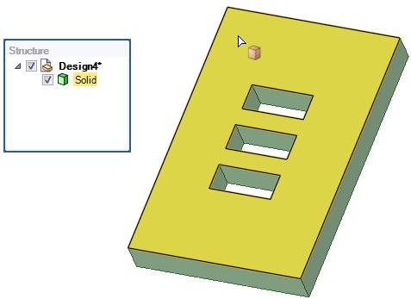

Concentric Cutouts
# Source: AI Source: Provided by: [Data Path: Persons Table -> ID Column: 1, Name_En Column: Motasem Essam] -> From: [ChatGPT] on [7/25/2026]
Two or more cut-outs share a common center.
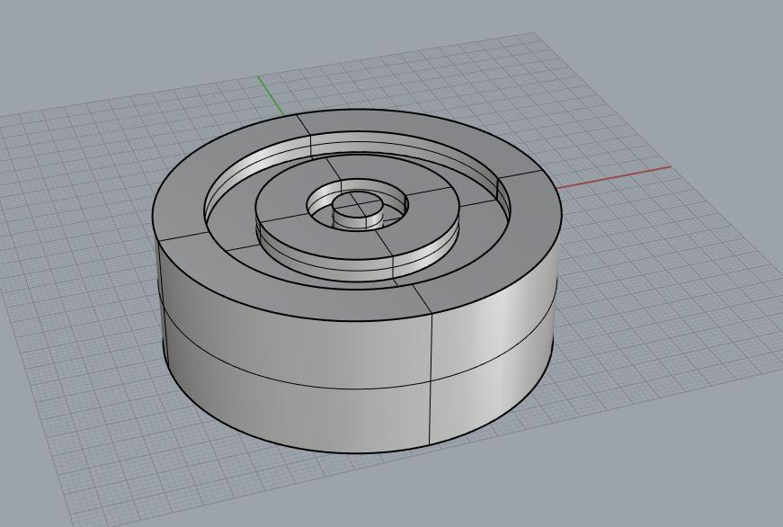

Distributed Cutouts
# Source: AI Source: Provided by: [Data Path: Persons Table -> ID Column: 1, Name_En Column: Motasem Essam] -> From: [ChatGPT] on [7/25/2026]
Cut-outs are distributed across different locations of the solid.
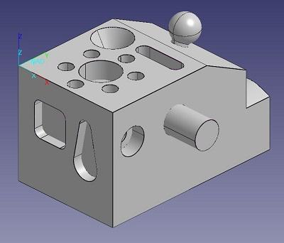

Intersecting Cutouts
# Source: AI Source: Provided by: [Data Path: Persons Table -> ID Column: 1, Name_En Column: Motasem Essam] -> From: [ChatGPT] on [7/25/2026]
Two or more removed regions overlap or intersect geometrically.
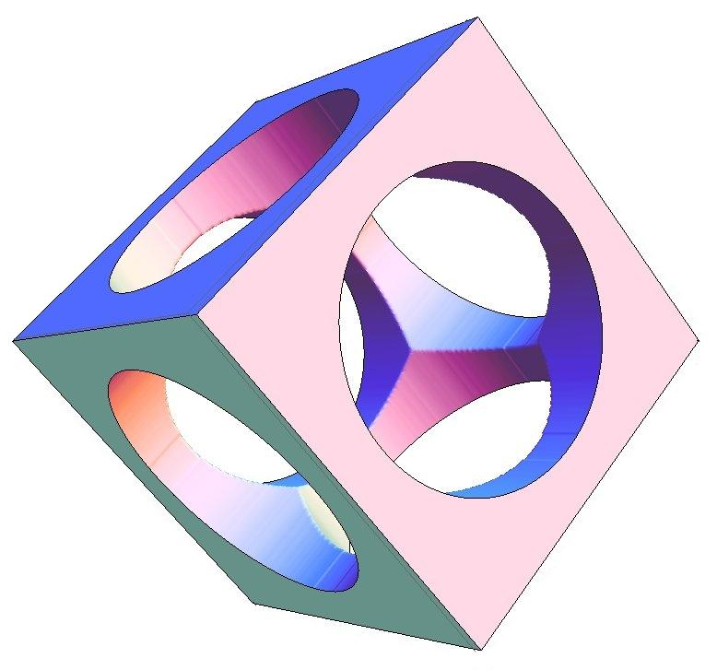

Nested Cutouts
# Source: AI Source: Provided by: [Data Path: Persons Table -> ID Column: 1, Name_En Column: Motasem Essam] -> From: [ChatGPT] on [7/25/2026]
A smaller cut-out is located within a larger cut-out region.
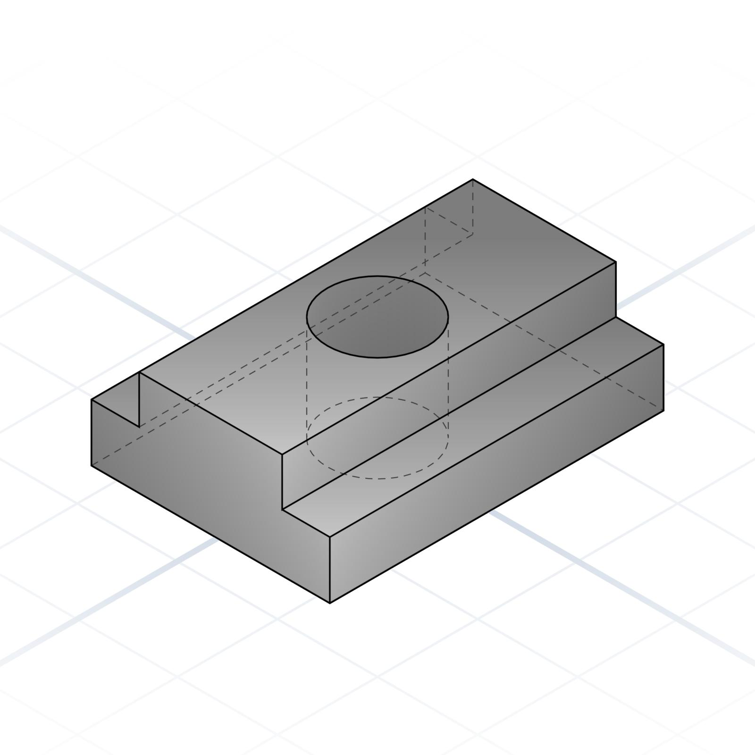

Grid-Based Cutouts
# Source: AI Source: Provided by: [Data Path: Persons Table -> ID Column: 1, Name_En Column: Motasem Essam] -> From: [ChatGPT] on [7/25/2026]
Cut-outs are arranged in rows and columns to form a regular pattern.
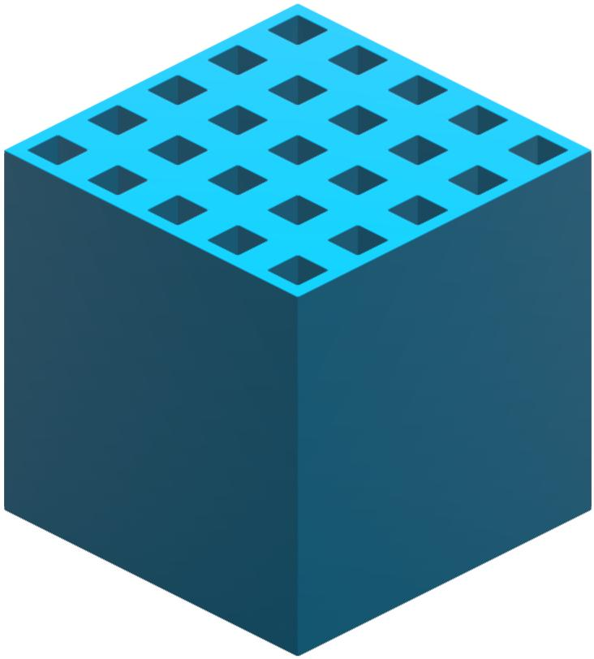

Classification by Number of Cutouts
# Source: AI Source: Provided by: [Data Path: Persons Table -> ID Column: 1, Name_En Column: Motasem Essam] -> From: [ChatGPT] on [7/25/2026]
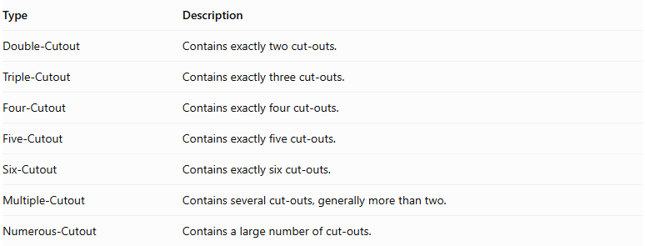
Type | Description
Double-Cutout | Contains exactly two cut-outs.
Triple-Cutout | Contains exactly three cut-outs.
Four-Cutout | Contains exactly four cut-outs.
Five-Cutout | Contains exactly five cut-outs.
Six-Cutout | Contains exactly six cut-outs.
Multiple-Cutout | Contains several cut-outs, generally more than two.
Numerous-Cutout | Contains a large number of cut-outs.
The number of cut-outs refers to distinct removed regions, not necessarily the number of visible openings. For example, one continuous passage may create two visible openings on opposite faces.

Classification by Depth and Extent
# Source: AI Source: Provided by: [Data Path: Persons Table -> ID Column: 1, Name_En Column: Motasem Essam] -> From: [ChatGPT] on [7/25/2026]
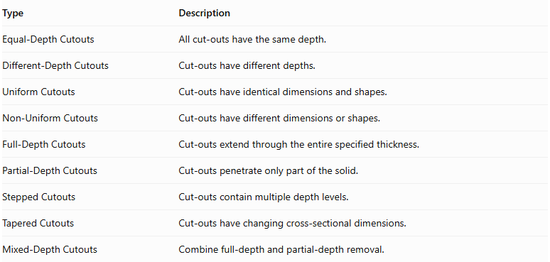
Type | Description
Equal-Depth Cutouts | All cut-outs have the same depth.
Different-Depth Cutouts | Cut-outs have different depths.
Uniform Cutouts | Cut-outs have identical dimensions and shapes.
Non-Uniform Cutouts | Cut-outs have different dimensions or shapes.
Full-Depth Cutouts | Cut-outs extend through the entire specified thickness.
Partial-Depth Cutouts | Cut-outs penetrate only part of the solid.
Stepped Cutouts | Cut-outs contain multiple depth levels.
Tapered Cutouts | Cut-outs have changing cross-sectional dimensions.
Mixed-Depth Cutouts | Combine full-depth and partial-depth removal.
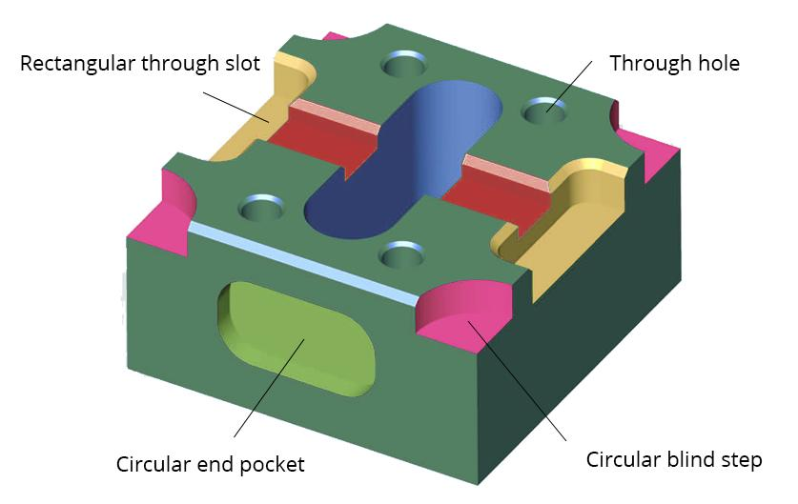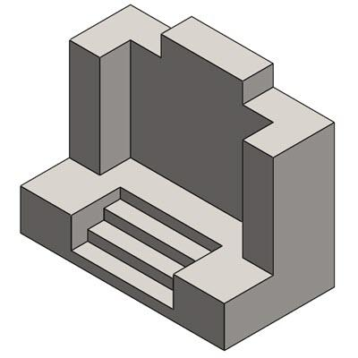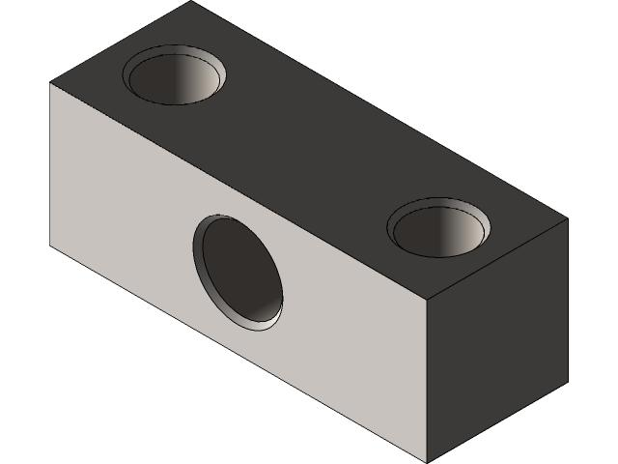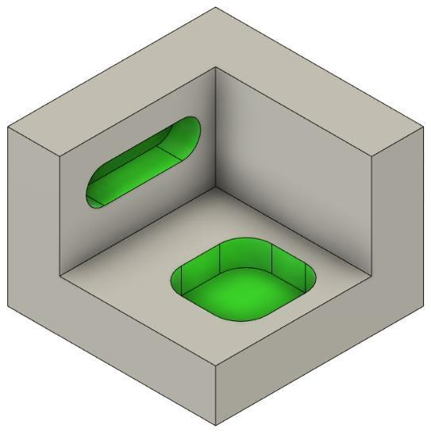

Classification by Component Relationship
# Source: AI Source: Provided by: [Data Path: Persons Table -> ID Column: 1, Name_En Column: Motasem Essam] -> From: [ChatGPT] on [7/25/2026]
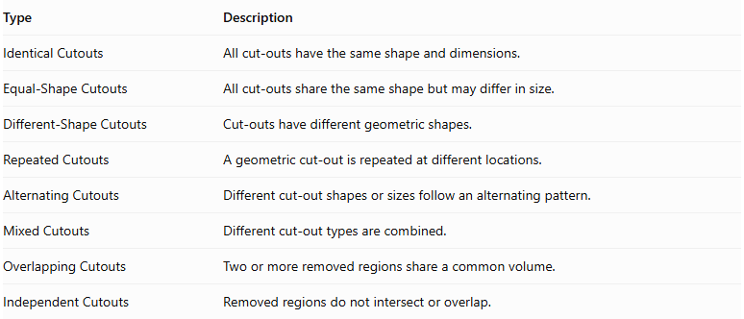
Type | Description
Identical Cutouts | All cut-outs have the same shape and dimensions.
Equal-Shape Cutouts | All cut-outs share the same shape but may differ in size.
Different-Shape Cutouts | Cut-outs have different geometric shapes.
Repeated Cutouts | A geometric cut-out is repeated at different locations.
Alternating Cutouts | Different cut-out shapes or sizes follow an alternating pattern.
Mixed Cutouts | Different cut-out types are combined.
Overlapping Cutouts | Two or more removed regions share a common volume.
Independent Cutouts | Removed regions do not intersect or overlap.

Mathematical Properties and Formulas

Remaining Volume
# Source: AI Source: Provided by: [Data Path: Persons Table -> ID Column: 1, Name_En Column: Motasem Essam] -> From: [ChatGPT] on [7/25/2026]
The remaining volume is calculated by subtracting the combined removed volume from the original solid's volume.
For non-overlapping cut-outs:
$$\boxed{V_{r}=V_{o}-\sum_{i=1}^{n}{V_{c_{i}}}}$$
Where:
- $V_{r}$ = Remaining volume.
- $V_{o}$ = Original solid volume.
- $V_{c_{i}}$ = Volume of the $i$-th cut-out.
- $n$ = Number of cut-outs.
For two overlapping removed regions:
$$\boxed{V_{r}=V_{o}-V_{1}-V_{2}+V_{overlap}}$$
The overlap is added back because it was subtracted twice.
For multiple overlapping regions, inclusion-exclusion principles or direct geometric union calculations may be required.

Common Cut-Out Volume Formulas
# Source: AI Source: Provided by: [Data Path: Persons Table -> ID Column: 1, Name_En Column: Motasem Essam] -> From: [ChatGPT] on [7/25/2026]
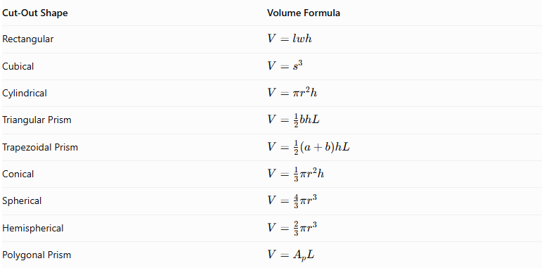
Cut-Out Shape | Volume Formula
Rectangular | $$V=lwh$$
Cubical | $$V=s^{3}$$
Cylindrical | $$V=πr^{2}h$$
Triangular Prism | $$V=\frac{1}{2}bhL$$
Trapezoidal Prism | $$V=\frac{1}{2}(a+b)hL$$
Conical | $$V=\frac{1}{3}πr^{2}h$$
Spherical | $$V=\frac{4}{3}πr^{3}$$
Hemispherical | $$V=\frac{2}{3}πr^{3}$$
Polygonal Prism | $$V=A_{pL}$$

Surface Area
# Source: AI Source: Provided by: [Data Path: Persons Table -> ID Column: 1, Name_En Column: Motasem Essam] -> From: [ChatGPT] on [7/25/2026]
The remaining surface area is determined by removing the original exterior regions affected by the cut-outs and adding the newly exposed internal surfaces.
$$\boxed{{SA}_{r}={SA}_{o}-A_{removed}+A_{new}}$$
Where:
- ${SA}_{r}$ = Remaining external surface area.
- ${SA}_{o}$ = Original external surface area.
- $A_{removed}$ = Total original exterior area removed.
- $A_{new}$ = Total newly exposed surface area.
For multiple independent cut-outs:
$${SA}_{r}={SA}_{o}-\sum{A_{removed,i}}+\sum{A_{new,i}}$$
This simple summation requires that the affected surface regions do not overlap and that the new surfaces do not intersect. Otherwise, shared and intersecting regions must be accounted for.
Important: The surface area of a solid cannot generally be found by subtracting the complete surface areas of the removed solids. Only the original exterior surfaces that disappear are subtracted, while the newly exposed surfaces are added.

Worked Examples

Example 1: Multiple Rectangular Cutouts
# Source: AI Source: Provided by: [Data Path: Persons Table -> ID Column: 1, Name_En Column: Motasem Essam] -> From: [ChatGPT] on [7/25/2026]
A rectangular prism has dimensions:
- Length = 12 cm
- Width = 10 cm
- Height = 8 cm
Two rectangular cut-outs are removed from its top surface.
Each cut-out has:
- Length = 3 cm
- Width = 2 cm
- Depth = 2 cm
Assume both cut-outs are independent, fully contained within the top face, and have vertical walls and flat bottoms.
Find the remaining volume and surface area.
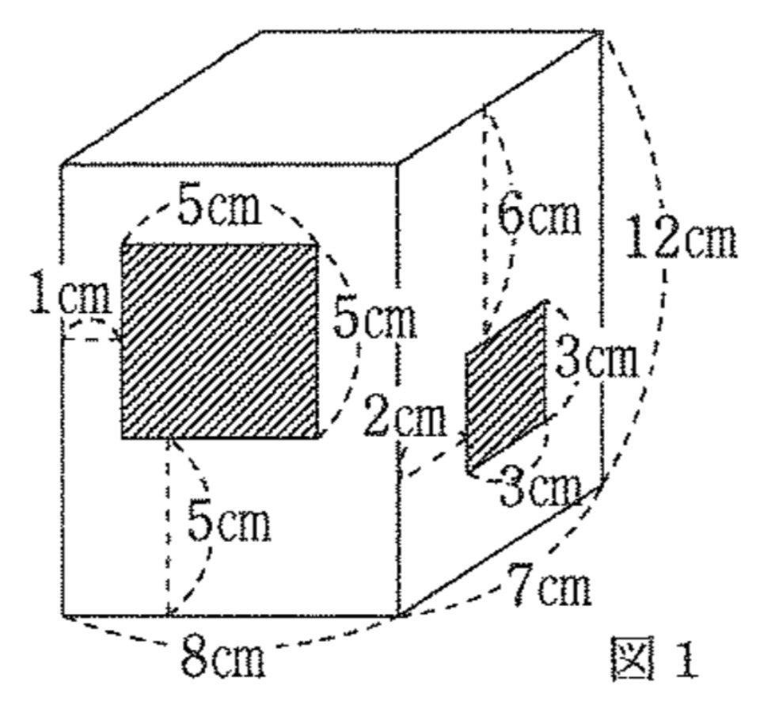
Step 1: Calculate the original volume.
$$V_{o}=12×10×8$$
$$V_{o}=960{ cm}^{3}$$
Step 2: Calculate the volume of one cut-out.
$$V_{1}=3×2×2$$
$$V_{1}=12{ cm}^{3}$$
Step 3: Calculate the total removed volume.
$$V_{c}=2×12$$
$$V_{c}=24{ cm}^{3}$$
Step 4: Calculate the remaining volume.
$$V_{r}=960-24$$
$$\boxed{V_{r}=936{ cm}^{3}}$$
Step 5: Calculate the original surface area.
$${SA}_{o}=2(lw+lh+wh)$$
$$=2(120+96+80)$$
$${SA}_{o}=592{ cm}^{2}$$
Step 6: Calculate the new internal surface area.
For each rectangular cut-out, the opening and bottom areas are equal and cancel each other.
The four internal walls of one cut-out have area:
$$A_{walls}=2(3×2)+2(2×2)$$
$$=12+8=20{ cm}^{2}$$
For two cut-outs:
$$A_{new}=2×20=40{ cm}^{2}$$
Therefore:
$${SA}_{r}=592+40$$
$$\boxed{{SA}_{r}=632{ cm}^{2}}$$
Final Answer:
- Remaining Volume = 936 cm³
- Remaining Surface Area = 632 cm²

Example 2: Mixed Circular and Rectangular Cutouts
# Source: AI Source: Provided by: [Data Path: Persons Table -> ID Column: 1, Name_En Column: Motasem Essam] -> From: [ChatGPT] on [7/25/2026]
A rectangular prism has dimensions:
- Length = 12 cm
- Width = 10 cm
- Height = 8 cm
Two cut-outs are removed from its top surface:
- A cylindrical cut-out with radius 2 cm and depth 4 cm.
- A rectangular cut-out with length 3 cm, width 2 cm, and depth 3 cm.
Assume both cut-outs are independent, do not intersect, and are fully contained within the top surface.
Find the remaining volume and surface area.
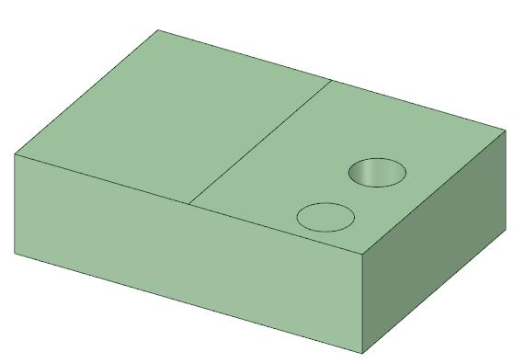
Step 1: Calculate the original volume.
$$V_{o}=12×10×8$$
$$V_{o}=960{ cm}^{3}$$
Step 2: Calculate the cylindrical cut-out volume.
$$V_{1}=πr^{2}h$$
$$=π(2)^{2}(4)$$
$$V_{1}=16π{ cm}^{3}$$
Step 3: Calculate the rectangular cut-out volume.
$$V_{2}=3×2×3$$
$$V_{2}=18{ cm}^{3}$$
Step 4: Calculate the remaining volume.
$$V_{r}=960-16π-18$$
$$\boxed{V_{r}≈891.73{ cm}^{3}}$$
Step 5: Calculate the original surface area.
$${SA}_{o}=2(120+96+80)$$
$${SA}_{o}=592{ cm}^{2}$$
Step 6: Calculate the new internal surfaces.
For the cylindrical cut-out, the opening and bottom areas cancel. Its newly exposed curved wall area is:
$$A_{1}=2πrh$$
$$=2π(2)(4)=16π$$
For the rectangular cut-out, the opening and bottom areas also cancel. Its newly exposed walls have area:
$$A_{2}=2(3×3)+2(2×3)$$
$$=18+12=30{ cm}^{2}$$
Step 7: Calculate the remaining surface area.
$${SA}_{r}=592+16π+30$$
$$\boxed{{SA}_{r}≈672.27{ cm}^{2}}$$
Final Answer:
- Remaining Volume = 891.73 cm³
- Remaining Surface Area = 672.27 cm²

Important Characteristics
# Source: AI Source: Provided by: [Data Path: Persons Table -> ID Column: 1, Name_En Column: Motasem Essam] -> From: [ChatGPT] on [7/25/2026]
- Two or more distinct portions of material are removed from an original solid.
- The cut-outs may have identical or different geometric shapes.
- Their dimensions and depths may be equal or different.
- Cut-outs may be located on the same face or different faces.
- They may be arranged symmetrically or asymmetrically.
- Cut-outs may be independent or intersecting.
- They may be through-cutouts, blind cutouts, surface depressions, notches, or grooves.
- The remaining volume is generally smaller than the original volume.
- The surface area may increase or decrease depending on the removed and newly exposed surfaces.
- The resulting solid may have a complex external boundary and multiple internal surfaces.

Comparison with Other Subtraction Methods
# Source: AI Source: Provided by: [Data Path: Persons Table -> ID Column: 1, Name_En Column: Motasem Essam] -> From: [ChatGPT] on [7/25/2026]
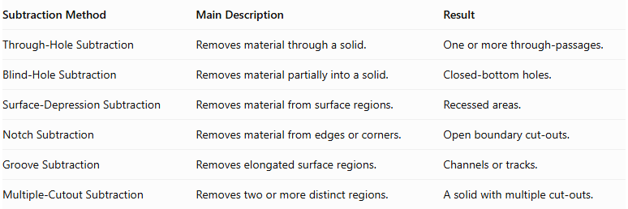
Subtraction Method | Main Description | Result
Through-Hole Subtraction | Removes material through a solid. | One or more through-passages.
Blind-Hole Subtraction | Removes material partially into a solid. | Closed-bottom holes.
Surface-Depression Subtraction | Removes material from surface regions. | Recessed areas.
Notch Subtraction | Removes material from edges or corners. | Open boundary cut-outs.
Groove Subtraction | Removes elongated surface regions. | Channels or tracks.
Multiple-Cutout Subtraction | Removes two or more distinct regions. | A solid with multiple cut-outs.
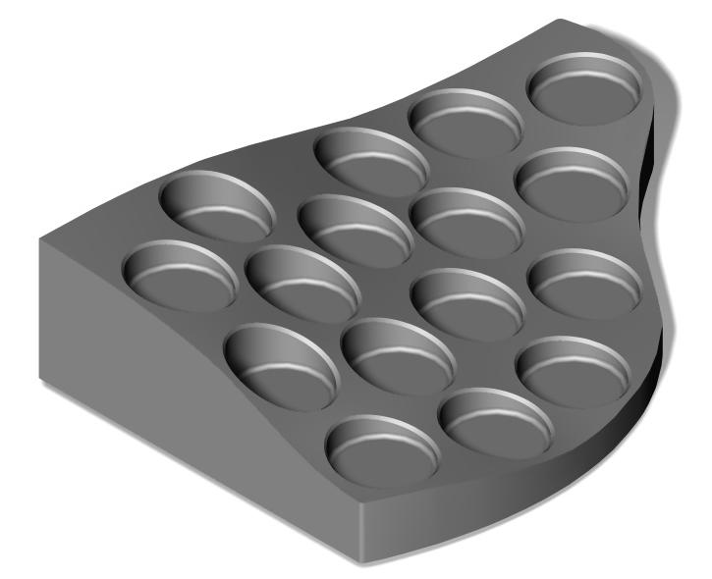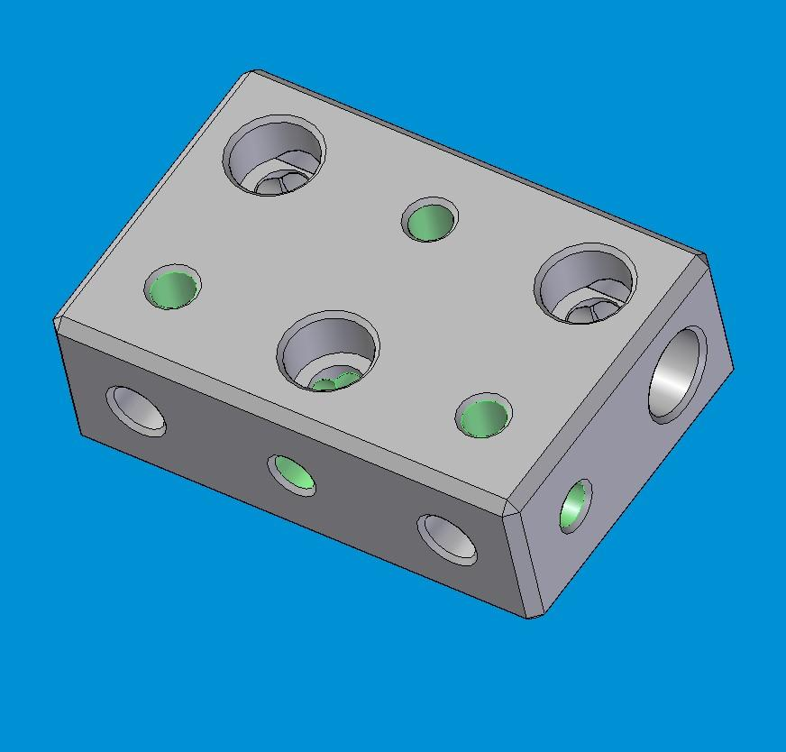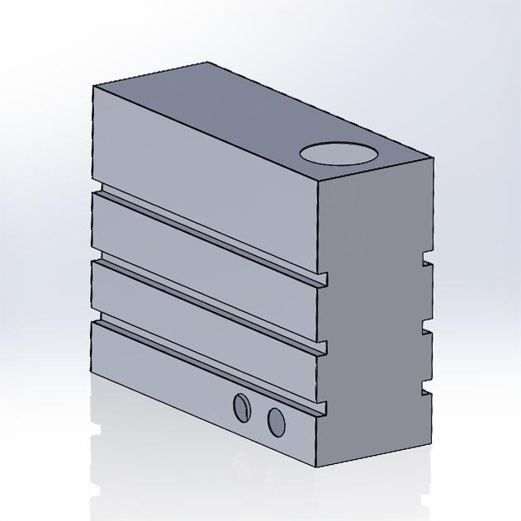
Important distinction: Multiple-cutout subtraction is classified primarily by the number of removed regions. It is not restricted to one particular cut-out shape or subtraction technique. A solid with multiple grooves, holes, or notches may also be classified as a multiple-cutout solid.

Applications
# Source: AI Source: Provided by: [Data Path: Persons Table -> ID Column: 1, Name_En Column: Motasem Essam] -> From: [ChatGPT] on [7/25/2026]
Multiple-cutout subtraction is commonly used in:
- Mechanical engineering: mounting holes, fitting openings, and component clearances.
- Manufacturing: machined parts with multiple openings and recesses.
- Architecture: ventilation openings and structural cut-outs.
- Construction: beams and panels with multiple service openings.
- Automotive engineering: lightweight components and mounting features.
- Aerospace engineering: weight-reduction cut-outs in structural components.
- Product design: housings with multiple openings and recessed controls.
- Electronics: circuit-board enclosures and component compartments.
- Furniture design: multiple openings and interlocking features.
- Industrial design: perforated panels and patterned solid structures.

Key Points
# Source: AI Source: Provided by: [Data Path: Persons Table -> ID Column: 1, Name_En Column: Motasem Essam] -> From: [ChatGPT] on [7/25/2026]
- Multiple-cutout subtraction involves removing two or more regions from an existing solid.
- Cut-outs may have identical or different shapes and dimensions.
- They can be classified by shape, type, arrangement, number, depth, and component relationship.
- Independent removed volumes can be added together.
- Overlapping removed regions require overlap corrections.
- Surface-area calculations must account for both removed exterior areas and newly exposed internal surfaces.
- Multiple-cutout subtraction is a broad category that can include combinations of holes, grooves, notches, and depressions.

Conclusion
# Source: AI Source: Provided by: [Data Path: Persons Table -> ID Column: 1, Name_En Column: Motasem Essam] -> From: [ChatGPT] on [7/25/2026]
Multiple-Cutout Subtraction is an important classification of composite solids formed by subtraction. It involves removing two or more distinct regions of material from an original solid to create multiple openings, recesses, or cut-out sections.
These cut-outs can vary in geometric shape, size, depth, and arrangement. By identifying each removed region and accounting for overlaps, the remaining volume and external surface area can be calculated accurately.

